JOhjjj

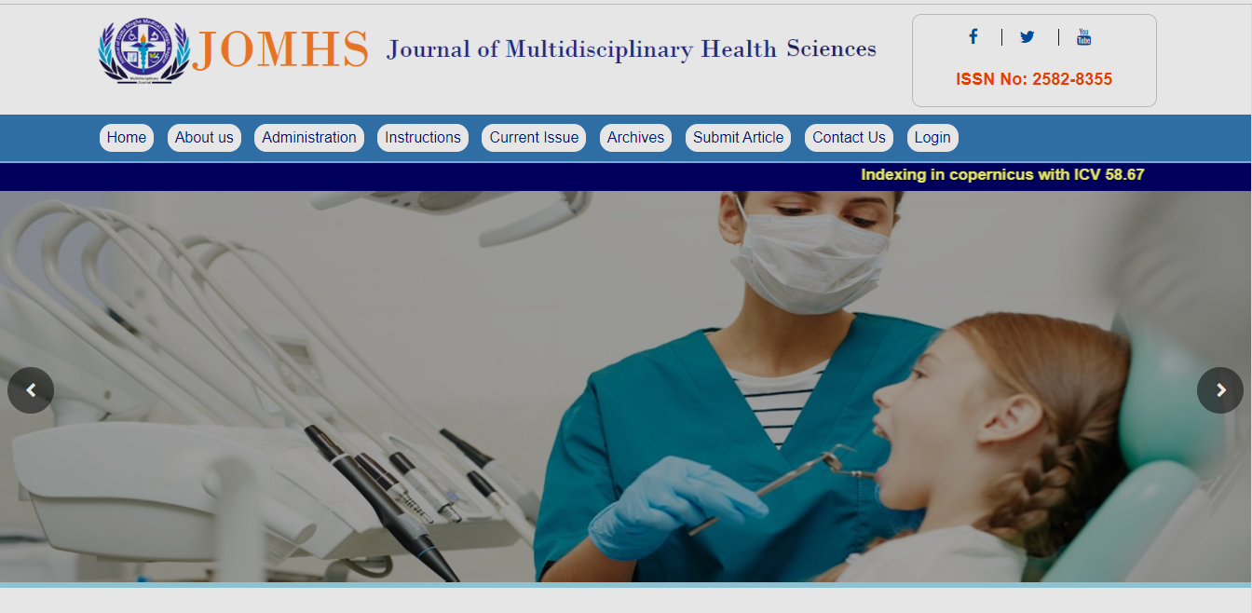

**JOMHS**

**Website**

**User Manual**

**Introduction**

Journal of Multidisciplinary Health Sciences (JOMHS) a publication of Datta Meghe Medical College, Wanadongari campus, Nagpur is a peer-reviewed online journal with Quarterly issues published. The journal’s full text is available online at http://jomhs.com. The journal allows free access (Open Access) to its contents and permits authors to self-archive final accepted version of the articles on any OAI-compliant institutional / subject-based repository.

**Contains**

* **Home**
* **About US**
* Aim & Scope
* **Administration**
* Chief Patron
* Editorial Board
* Reviewer Board
* **Instructions**
* Instruction to author and Form
* Manu script Sample Doc
* **Current Issue**
* **Achieves**
* **Submit Articles**
* **Contact Us**
* **Login**
* Admin Dashboard
* Profile
* Issue Display
* Article Upload,
* Finalized
* User list

**Home**

On this page, we will get Information about websites Aim, Scope, Indexing, and Ethics along with Latest Published Journal.



**About Us**

On this page, we will get the Following Information about this websites

* INTRODUCTION

### AIM

### SCOPE

### Journal Ethics

### Editorial Policies

### Peer Review

### Redundant or duplicate publication

### Permissions to reproduce previously published material

### Patient consent forms

### Ethics committee approval

### Plagiarism

### Open Access Publication and Creative Commons Licensing

### Conflicts of interest

**------------------------------------------------------------------------------------------------**

**Administration**

* Chief Patron
* Editorial Board
* Reviewer Board

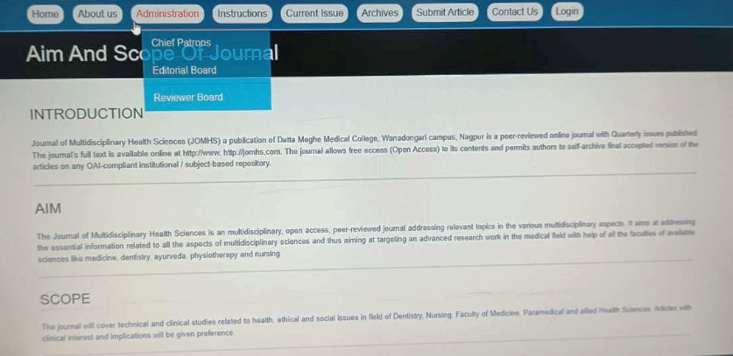

On this page, we will get the Following Information.

**Chief Patron-** Here we will get information about Chief Patron’s Members Name, Designation & Institutes.

**Editorial Board -**Here we will get information about **Editorial Board** Members Name, Designation & Institutes, Email ID, and Contact.

**Reviewer Board--**Here we will get information about **Reviewer Board** Members Name, Designation & Institutes, Email ID.

**------------------------------------------------------------------------------------------------**

**Instructions**

* Instruction to author and Form

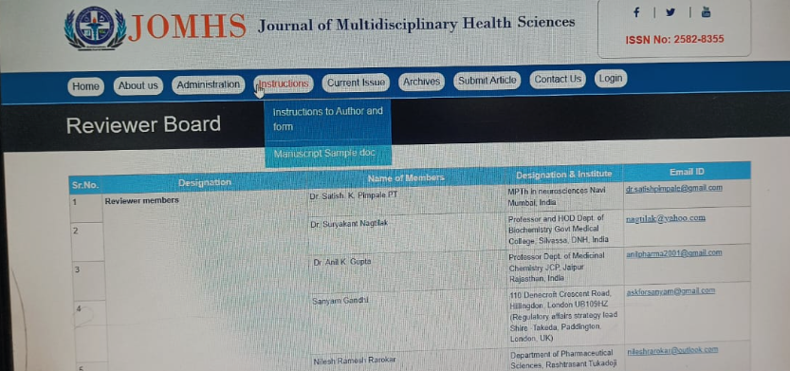

**Instruction to author and Form** Here information is provided for author regarding how to upload article types, Letters, Images, Research, Title ,Downloads ,Permissions, Submission.

We can download the declaration form by clicking on this link [**# Click to Download Author Declaration Form.**](http://jomhs.com/authorsdeclaration.pdf)

**------------------------------------------------------------------------------------------------**

**------------------------------------------------------------------------------------------------**

**Current Issue**

On this page we can get information about all uploaded articles. With images & author name.

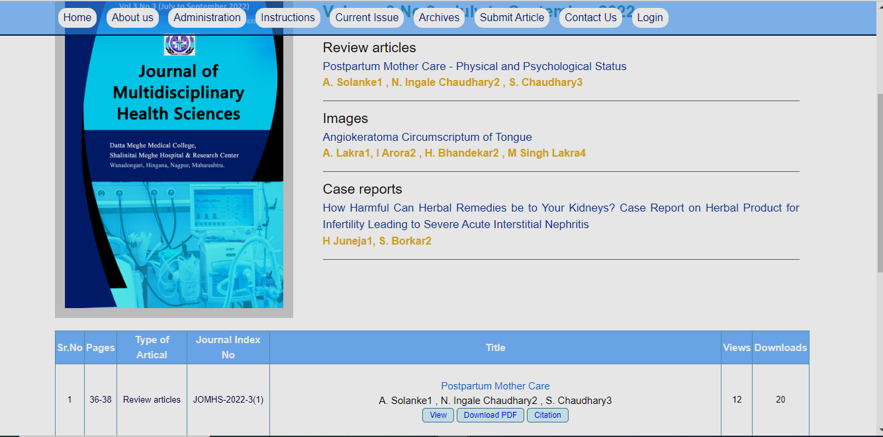

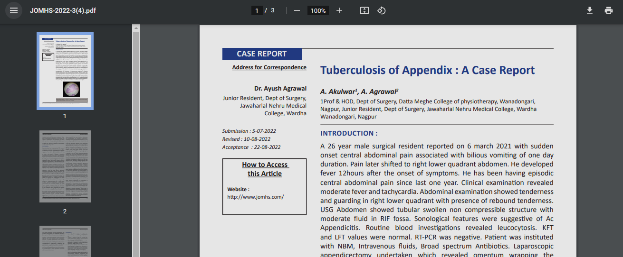

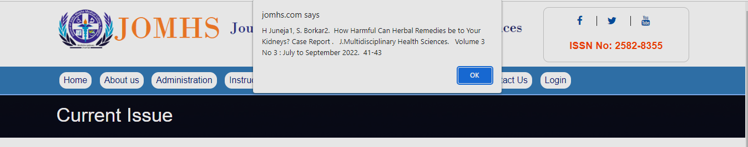

By clicking on this button we view details about article.

By clicking on this button we can get details as a notification.

By clicking on this button we can download the pdf of this article.

**Archives**

On this page we get recently uploaded articles

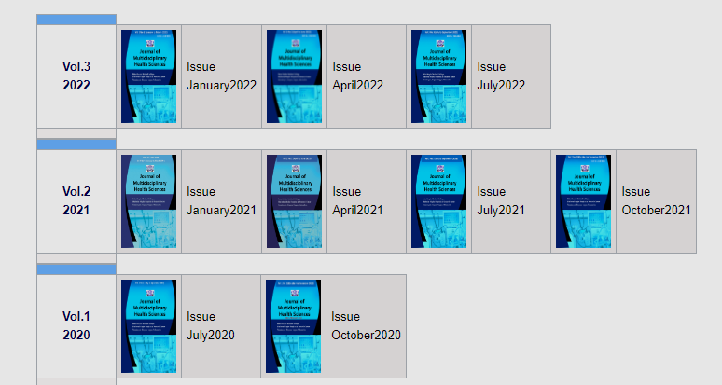

By clicking on this articles we get detailed information about the article

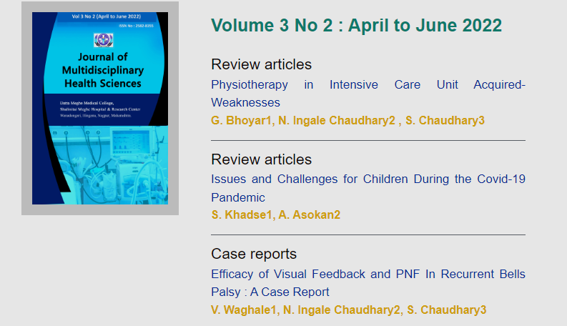

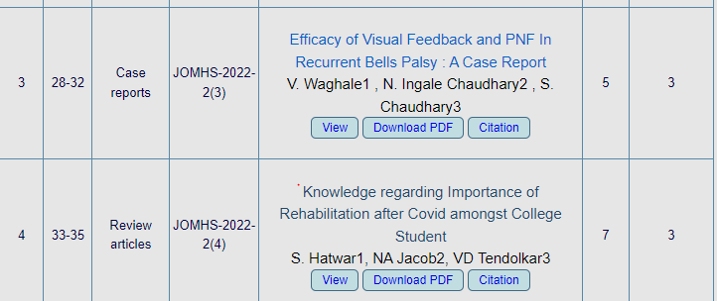

**------------------------------------------------------------------------------------------------**

**Submit Article**

On this page registered author can login with using username and password.

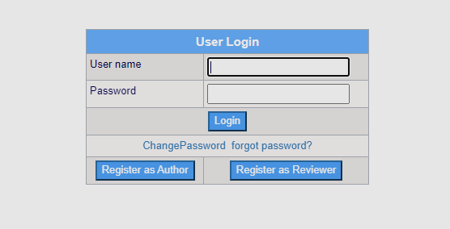

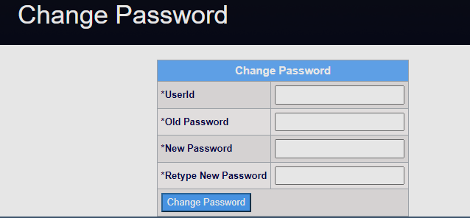

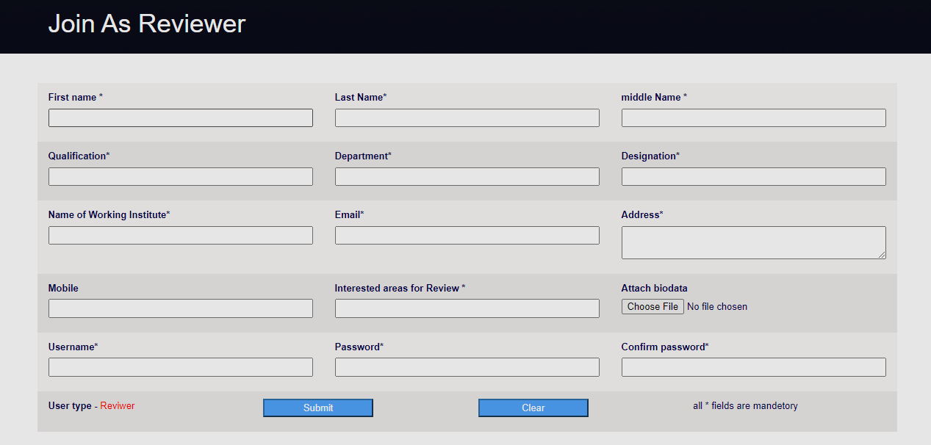

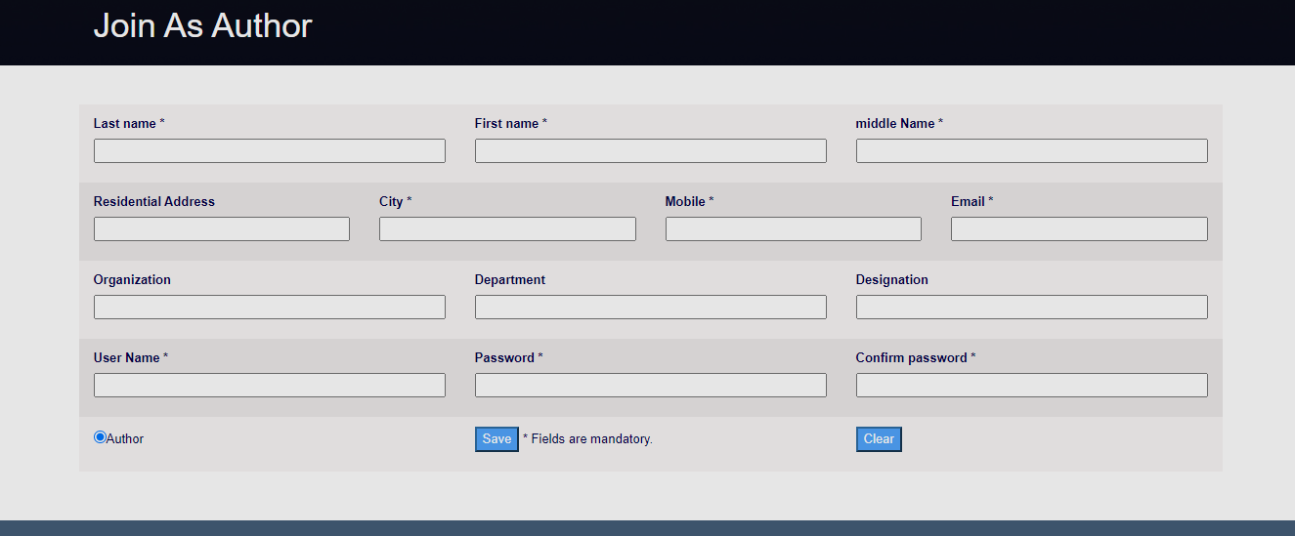

If you forgot the password click on the link forgot password

Enter the registered username, the generated password will send to your registered Email

If you want to Change the Current Password

Click on the link Change password, and enter the old password and set new password

I Reviewer is not registered Click on this button and fill the form below

I author is not registered Click on this button and fill the form below

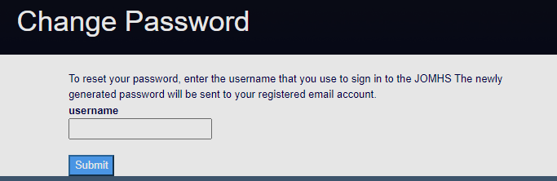

**Admin Dashboard**

**After successful login admin panel opens,**

Here we get information about new articles, Reviewed Articles, Rejected Article, Accepted Articles Published articles etc.

By clicking on each link we get detailed information about it.

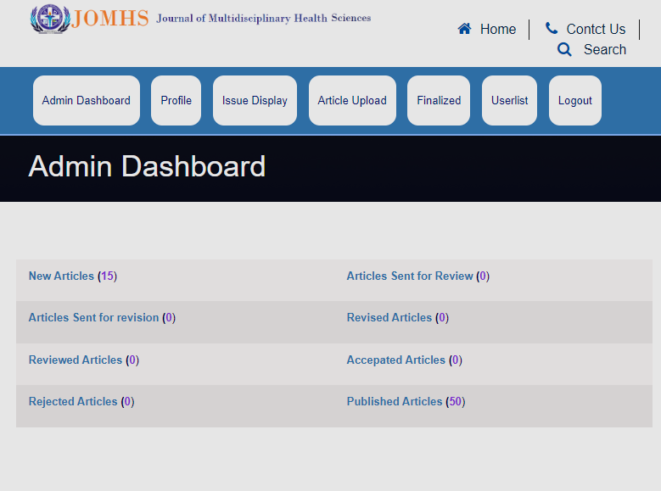

**------------------------------------------------------------------------------------------------**

**Profile**

On this page we get details of Current Logged Admin

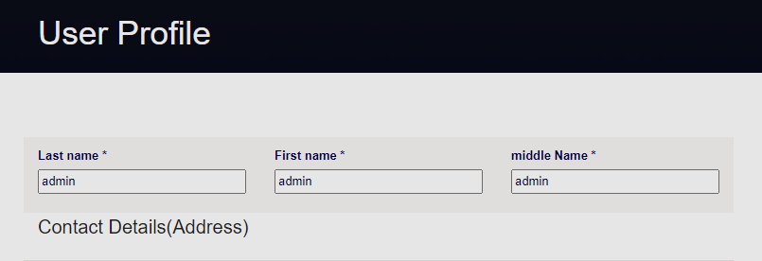

**------------------------------------------------------------------------------------------------**

**Issue Display**

On this page Admin can Upload the Issues with an image and complete details about article. Also admin is able to view details of previously uploaded Issues. Author can update and delete those Issues.

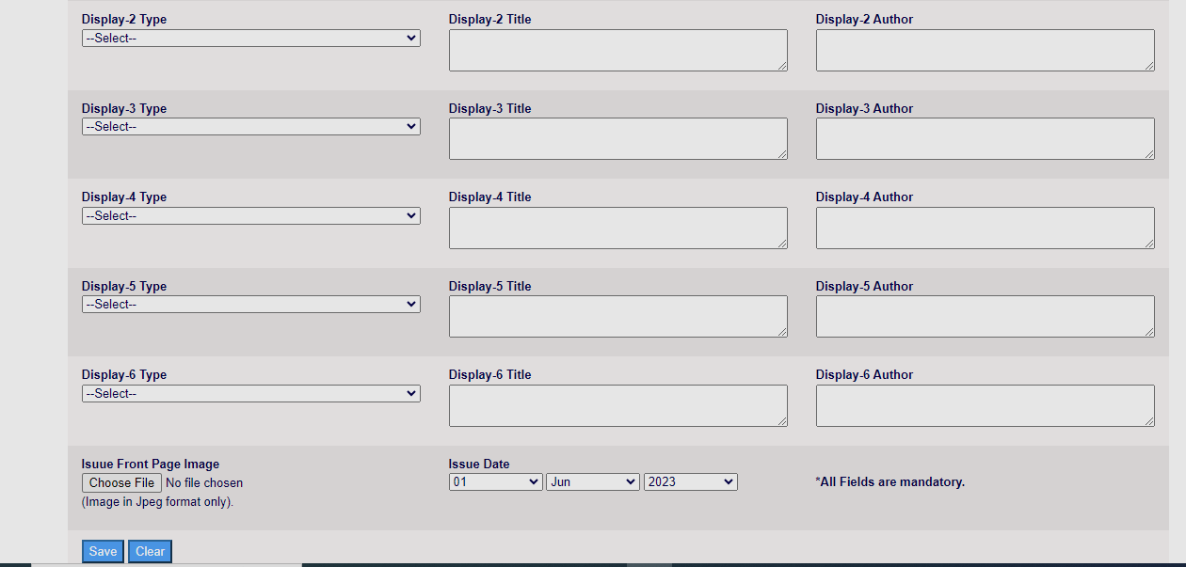

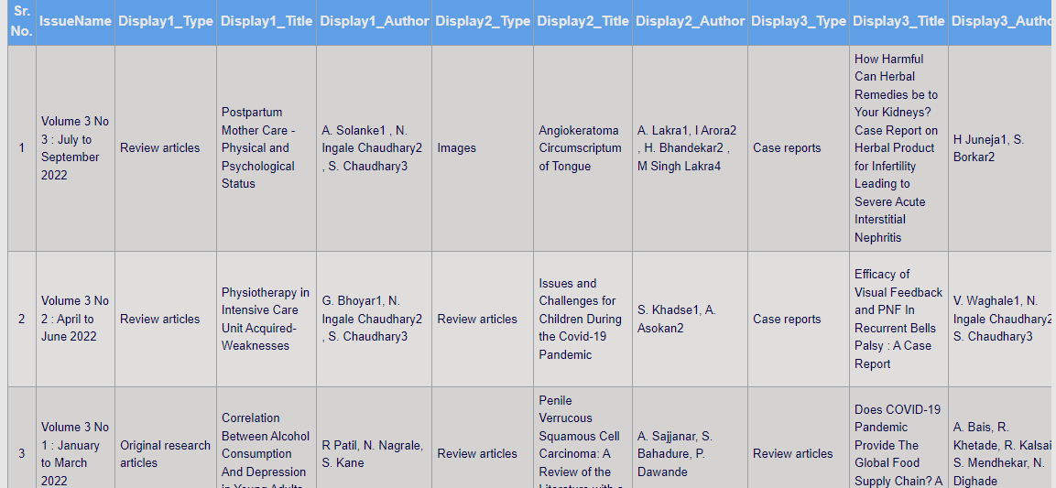

**------------------------------------------------------------------------------------------------**

**Article Upload**

On this page Admin can Upload the Articles with an image and complete details about article. Also admin is able to view details of previously uploaded Issues. Author can update and delete those article.

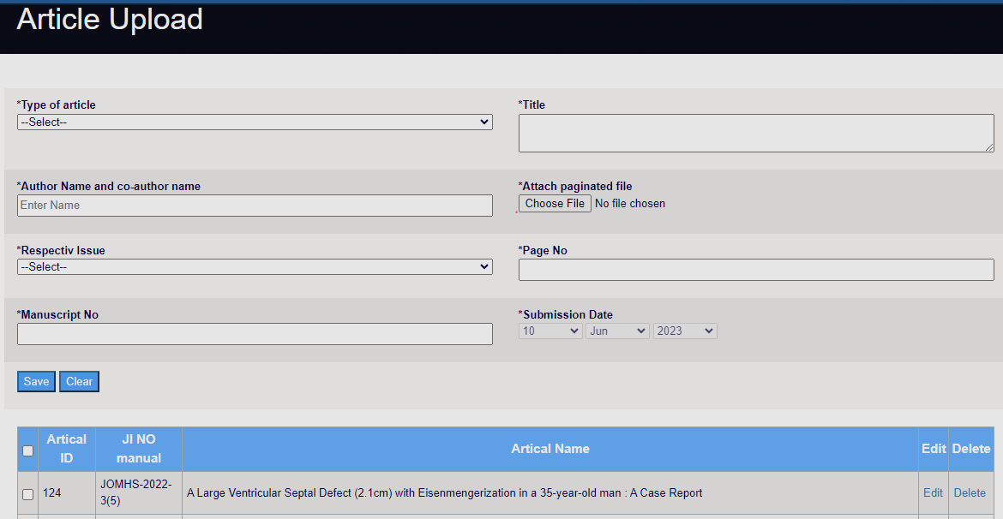

**-------------------------------------------------------------------------------------------------**

**Finalized**

This page contains detailed information about the Published and Rejected articles.

Published articles are highlighted in Green.

Rejected articles are highlighted in Blue. 

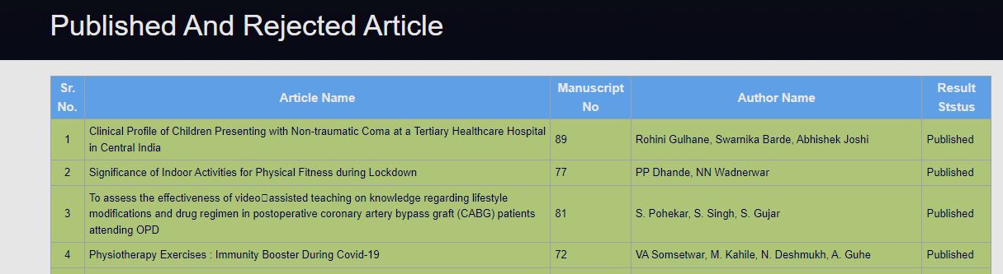

**-------------------------------------------------------------------------------------------------**

**User List**

Here is the complete details about the User list of this website

There is a count for total numbers of Author’s and Reviewer’s

Admin’s details are highlighted in Green. 

Author’s details are highlighted in Blue. 

Reviewer’s details are highlighted in Purple. 

Block details are highlighted in Red. 

**-------------------------------------------------------------------------------------------------**

**Contact Us**

On this pagePublisher’s Office’s address and registrar Office’s address is provided along with the Location (Google Map)Also we can send email by filling details.

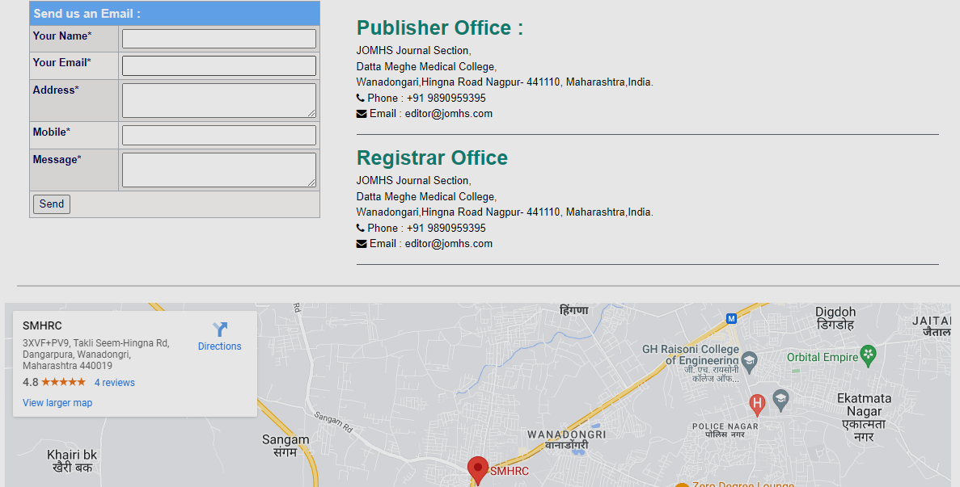.

**-------------Thank You----------**